

# Cairo University Faculty of Engineering Dept. of Electronics and Electrical Communications Second Year Analysis of Continuous-Time Signals ELC 2030

**Analysis of Continuous-Time Signals  
Image filtering and restoration &  
Communication system simulation   
project**

|  |  |  |
| --- | --- | --- |
| Student Name | Section | B.N. |
| يوسف اشرف محمد ابوطالب | 4 | 9220972 |
| يوسف خالد عمر محمود | 4 | 9220984 |

Presented by

**Instructors:** **Dr.** Michael Melek Abdel-Sayed

DNKDJJKVDS

FDSLKFNADSKLV

V/SFMKL

AKLNVAKL A

FAGA

## Task b

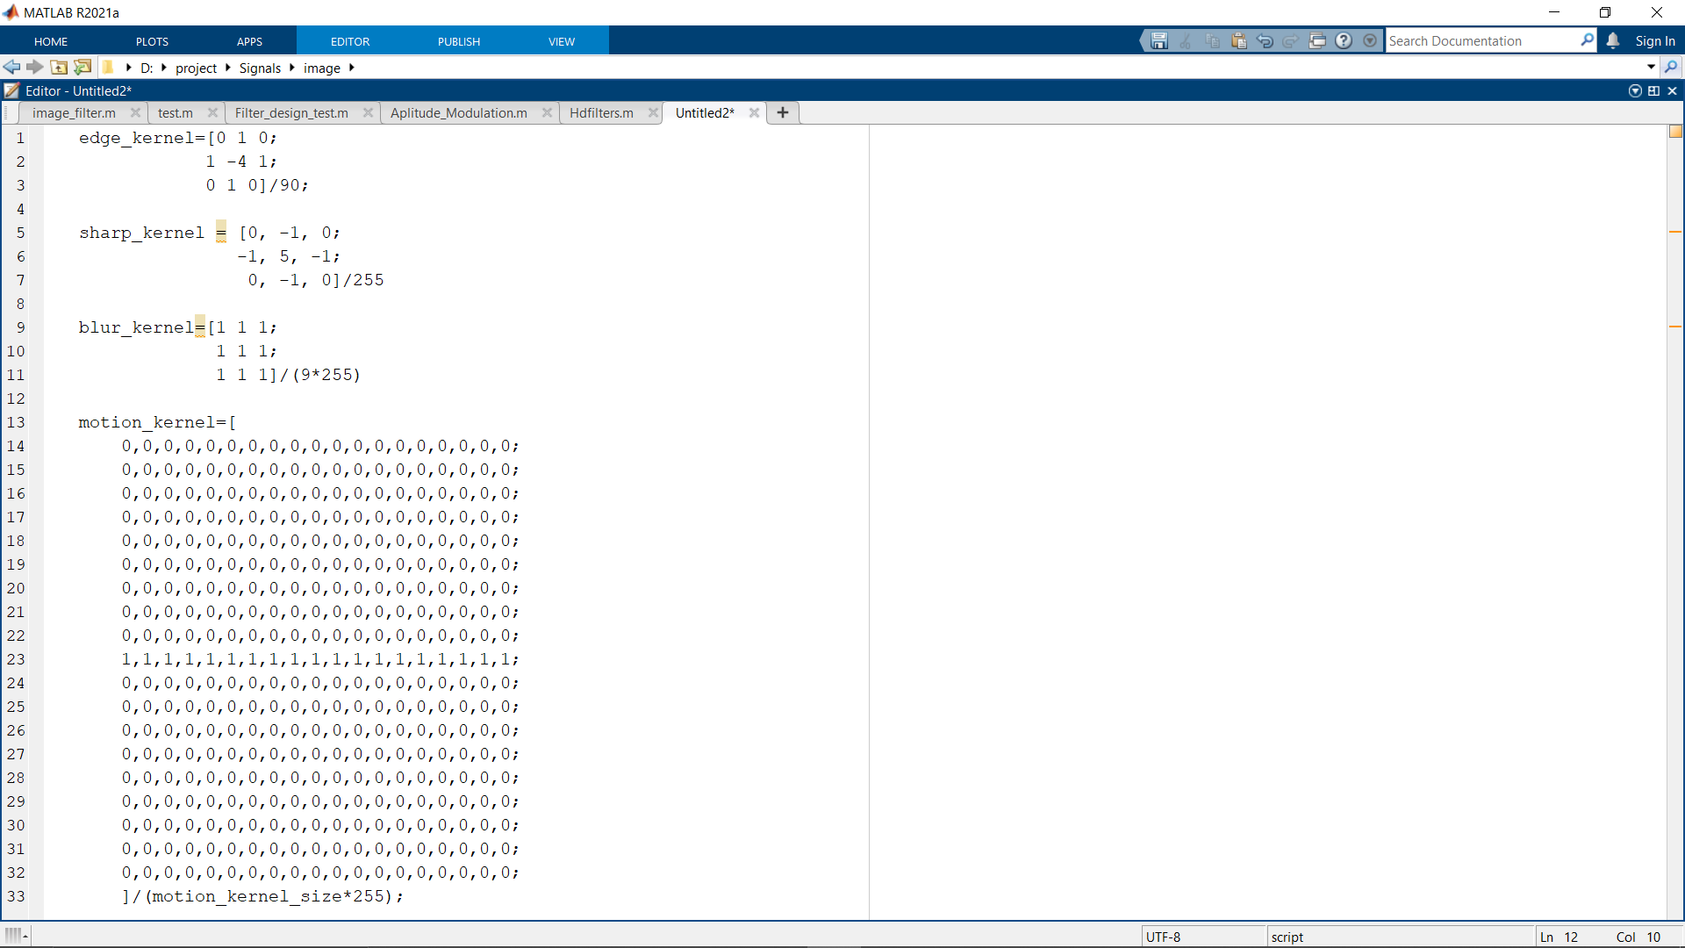

Figure 2 Kernels

As shown in *figure 2*, We used for each process a certain kernal and we will discuss each process with its kernel. [1]

## Edge:

Figure 3 Edge picture

$Edge= ^2 pic$*Equation 1*

As shown in *Equation 1* and *figure3*, the edge is the Laplacian of the picture so we made the kernel, shown in *figure 2*, that represent the Laplacian operator numerically and used it in section B of the image code.[2]

## Sharp:

Figure 4 Sharp Picture

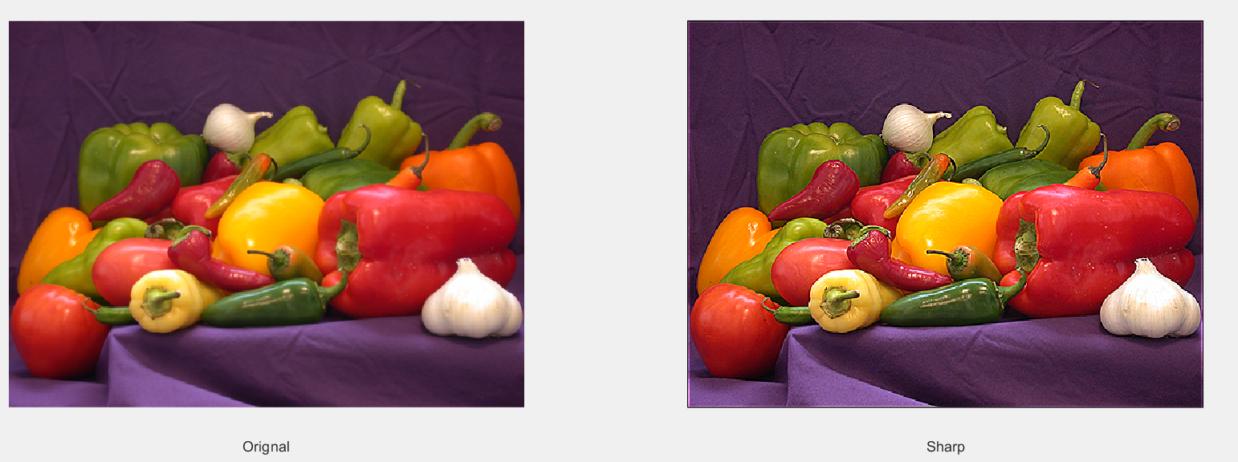

$Sharp= pic+^2 pic$*Equation 2*

As shown in *Equation 2* and *figure4*, the sharp is the sum of the Laplacian of the picture and the picture itself, so we made the kernel, shown in *figure 2*, that represent the Laplacian operator added with the orignal input numerically and used it in section C of the image code.[2]

## Blur:

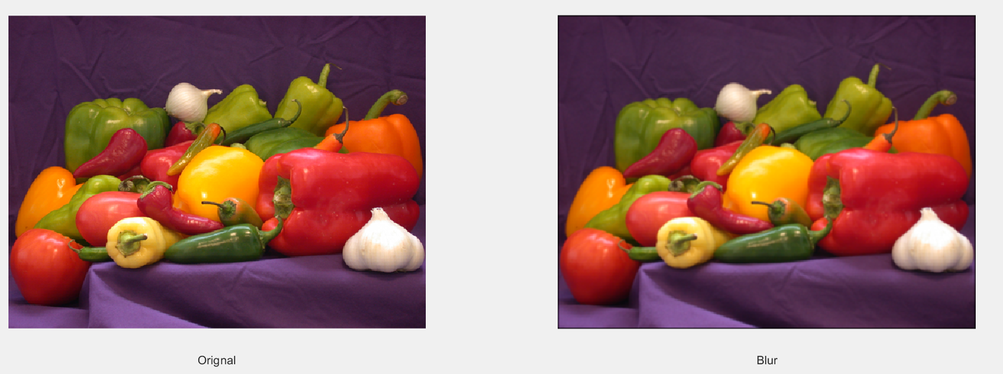

Figure 5 blur picture

$Blur=avg(picture)$*Equation 3*

As shown in *Equation 3* and *figure5*, the blur is the average of the picture, so we made the kernel, shown in *figure 2*, that represent the average operator of the orignal input and used it in section D of the image code.[3]

## Motion blur:

Figure 6 motion blur picture

$Motion blur=shift horizontal(picture)$*Equation 4*

As shown in *Equation 4* and *figure6*, the motion blur is the average of the picture, so we made the kernel, shown in *figure 2*, that represent the average operator of the orignal input and used it in section E of the image code.[4]

## Task c

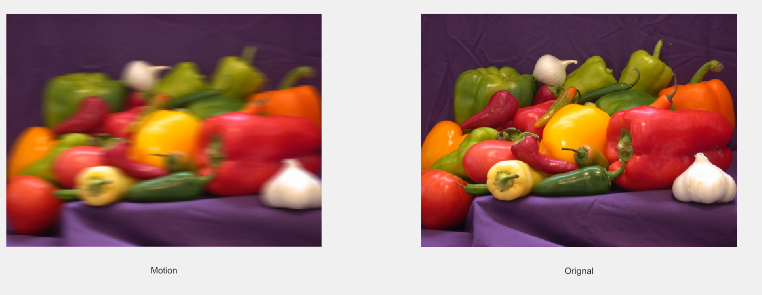

Figure 7 Restored picture

We know that:

$Motion picture(t)=Picture(t)*motion kernel(t)$*Equation 5*

But in frequency domain *Equation 5 will be:*

$Motion picture\left(w\right)=Picture\left(w\right) X motion kernel(w)$*Equation 6*

So to restore the orignal picture we will divide according to *Equation 6*, and to calculate the restored picture we will use:

$picture\left(w\right)=motion picture\left(w\right) / motion kernel(w)$*Equation 7*

So we first padded the motion kernel in section F of the image code then we fourier transformed both Motion picture and padded kernel to restore the picture according to *Equation 7.*

Then we inversed fourier transform the restored picture in frequency domain to become time domain.

When we display both motion and restored image, we crop them due to motion kernel effect.

# Communication system simulation:

## Explanation of my work :

* 1. First, we use matlab to record the voice using the record code. then we design a low bass filters with different cut-off frequency. Then in the filter code we chose the voice at cut-off frequency (20000 Hz &4000 Hz) to know what happened at this cut-off frequency, then we plot the input and the output record in different domain (time and frequency) and this is the result of two signal (records)[5].

## Why we chose this sampling frequency and bit depth?

* We chose sampling frequency (44100) just to improve the qulity of voice, we know we can use less than this number[6].

* We chose the bit depth (16-bit) because that is the ideal number of bits use to store the voice.

# First signal:

## the result at (20000 Hz):

Figure 8.the frequency response of the filter

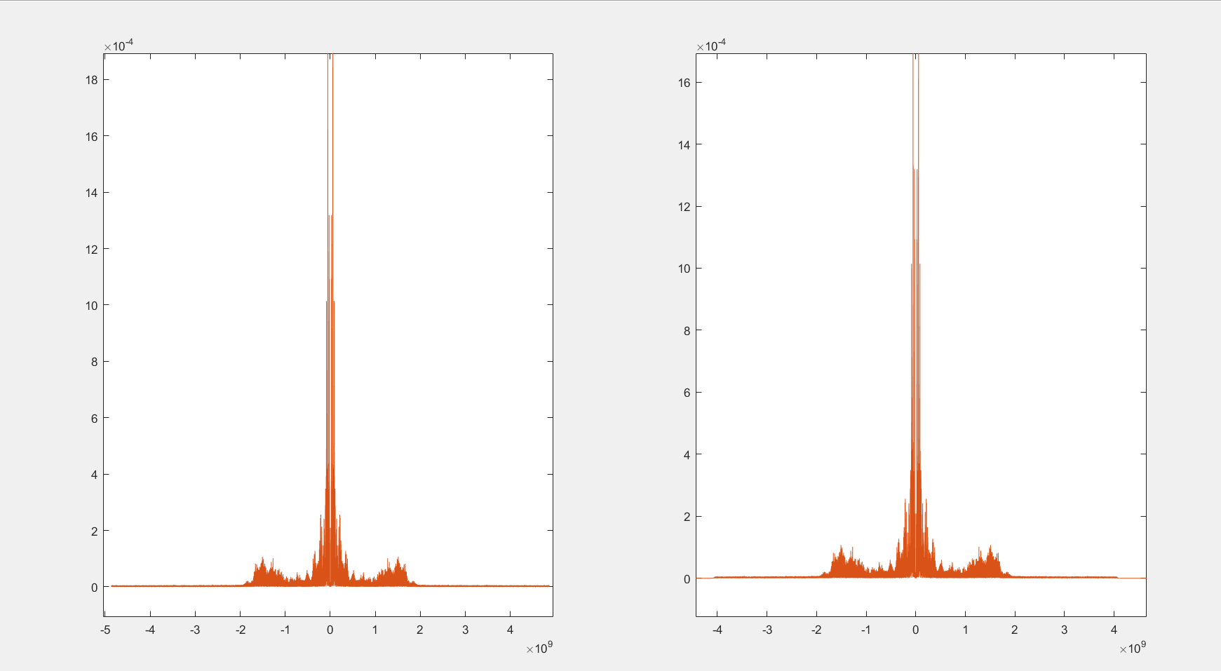

Figure 10.the magnitude spectrum of the first signal @20000 Hz.(input and output) in frequency response

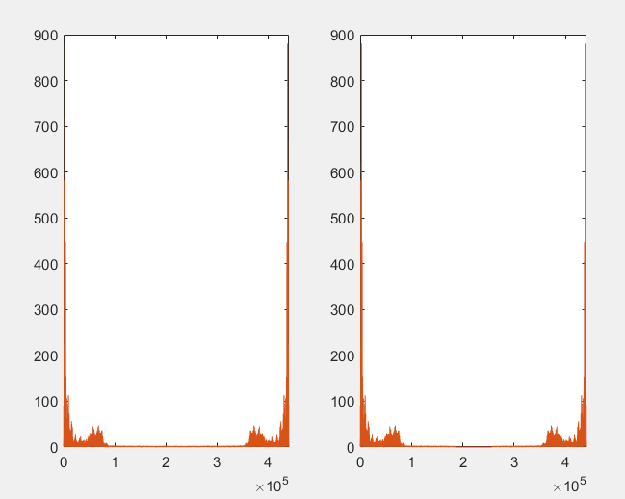

Figure 9.the magnitude spectrum of the first signal @2000 Hz.(input and output) (k)

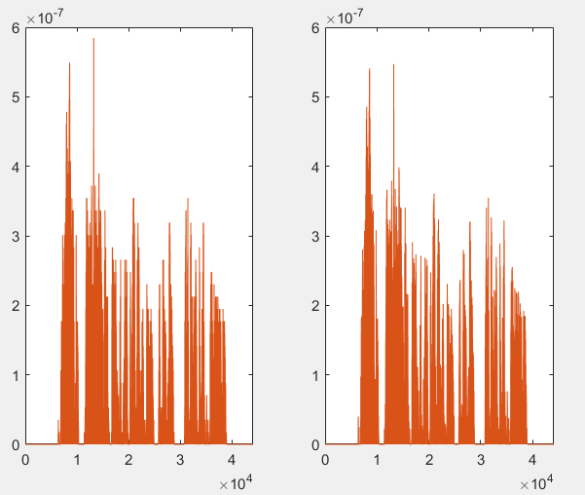

Figure 11 the magnitude spectrum of the first sgnal @20000 Hz.(input and output) (Hz)

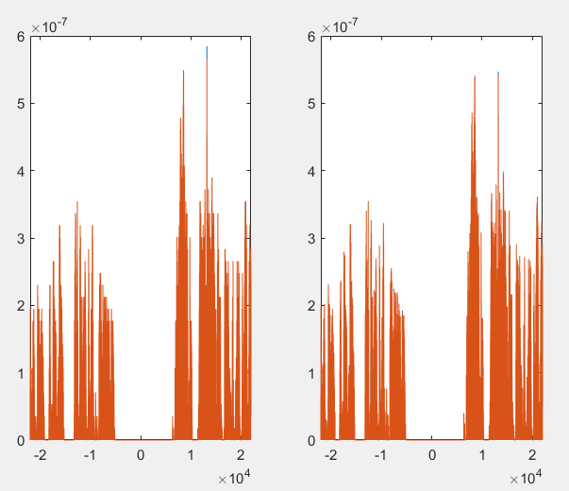

Figure 12.the magnitude spectrum of the first signal @20000 Hz.(input and output) (k) using fftshift’

## The results at (4000 Hz):

Figure 13.the frequency response of the filter(4000 hz)

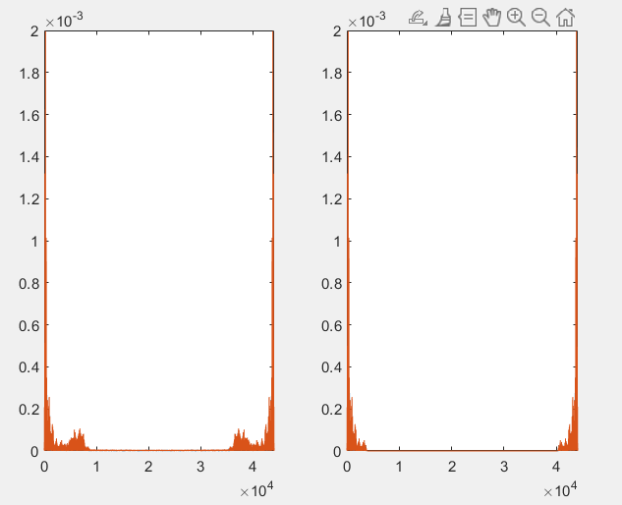

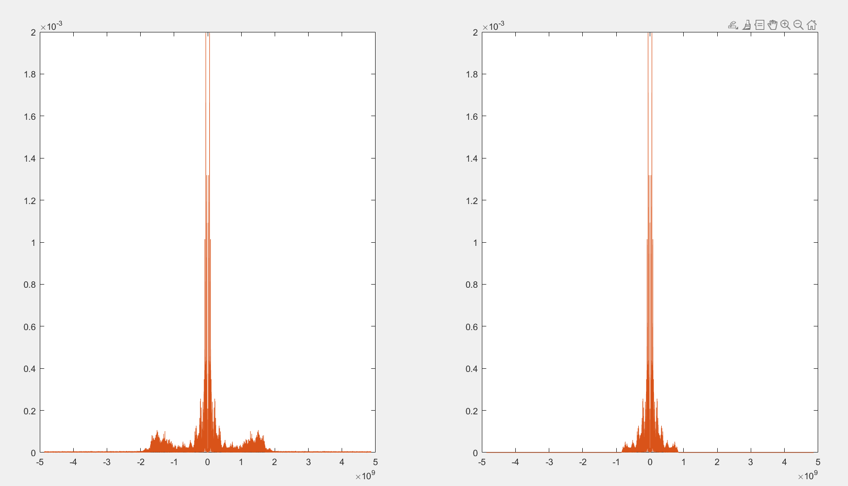

Figure 14..the magnitude spectrum of the first signal @4000 Hz.(input and output) in frequency response

Figure 15.the magnitude spectrum of the first signal @4000 Hz.(input and output) (k)

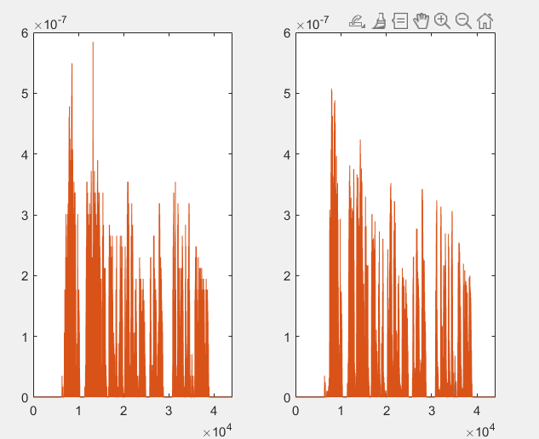

Figure 16.the magnitude spectrum of the first signal @4000 Hz.(input and output) (Hz)

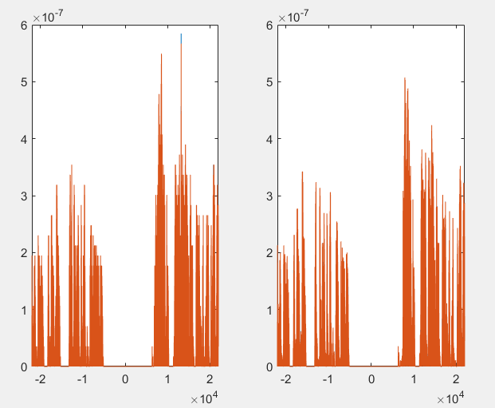

Figure 17 the magnitude spectrum of the first signal @4000 Hz.(input and output) (k) using fftshift’

# The second signal:

## the result at (20000 Hz):

Figure 18.the frequency response of the filter

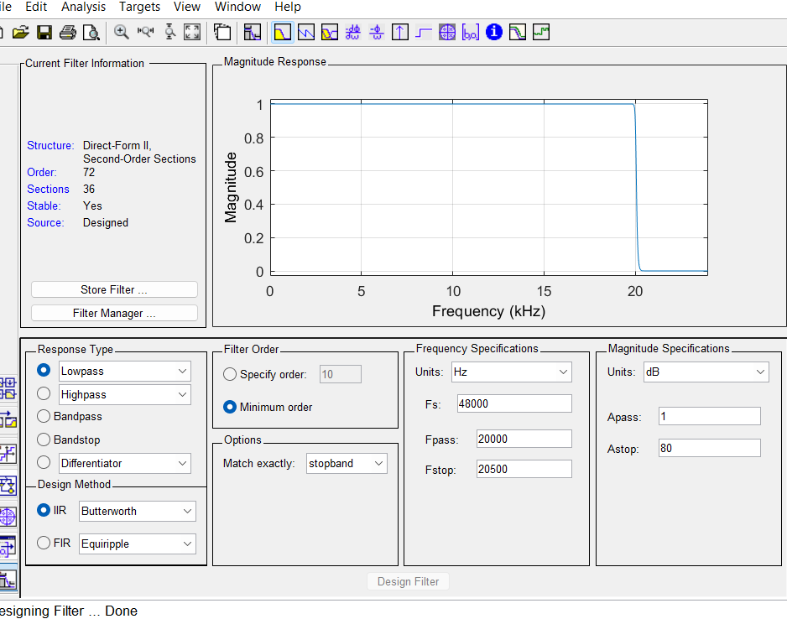

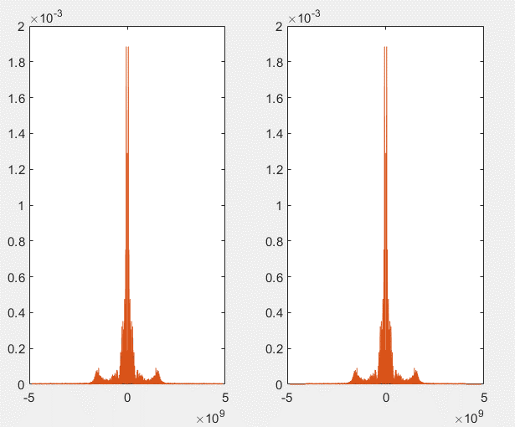

Figure 19.the magnitude spectrum of the second signal @20000 Hz.(input and output) in frequency response

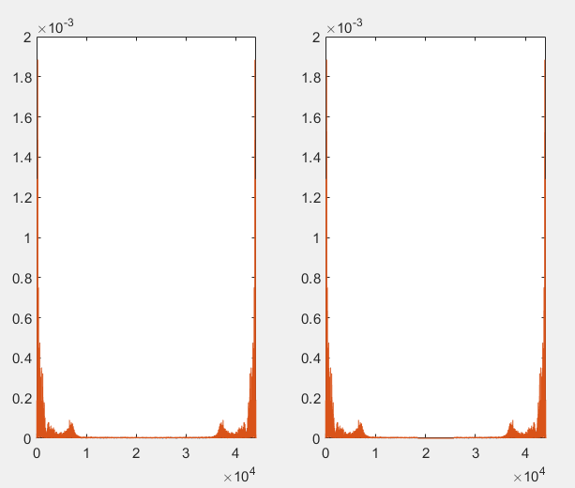

Figure 20.the magnitude spectrum of the second signal @20000 Hz.(input and output) (k)

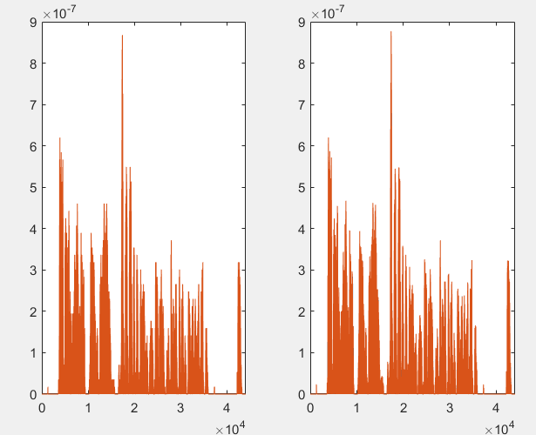

Figure 21.the magnitude spectrum of the second signal @20000 Hz.(input and output) (Hz)

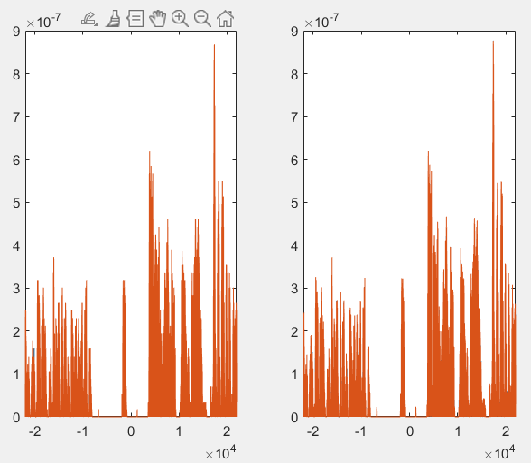

Figure 22.the magnitude spectrum of the second sgnal @20000 Hz.(input and output) using fftshift’

## the results at (4000 Hz):

Figure 23.the frequency response of the filter(4000 hz)

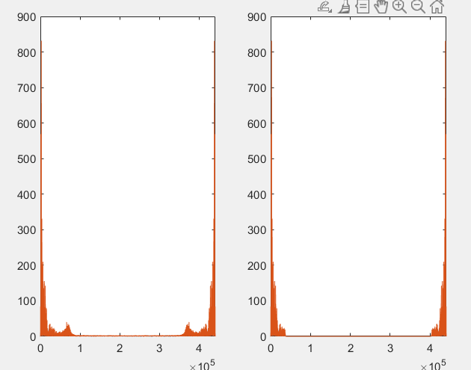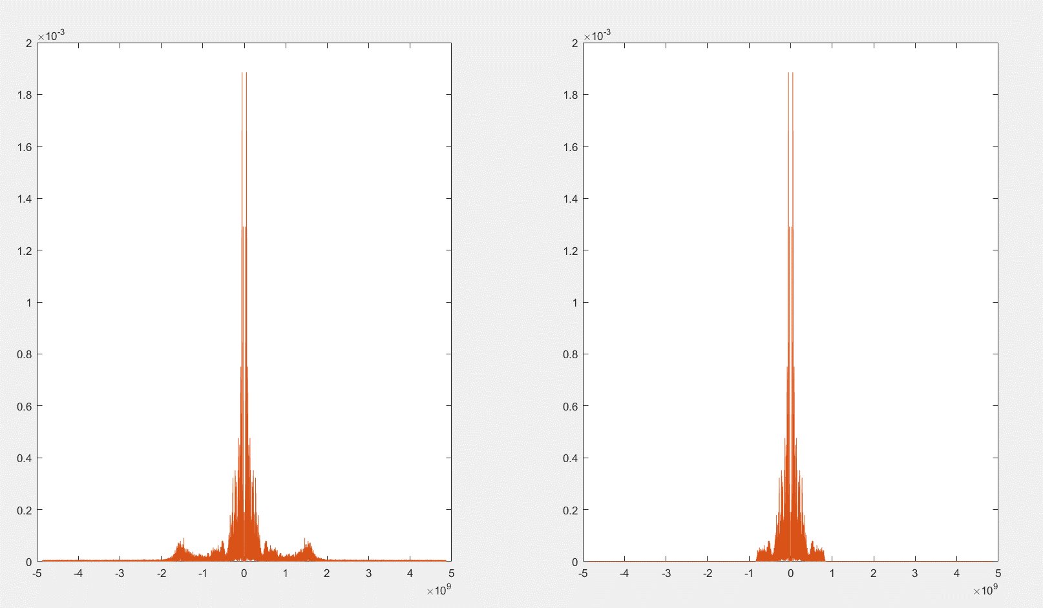

Figure 24.the magnitude spectrum of the second signal @4000 Hz.(input and output) in frequency response

Figure 25.the magnitude spectrum of the second signal @4000 Hz(input and output) (k)

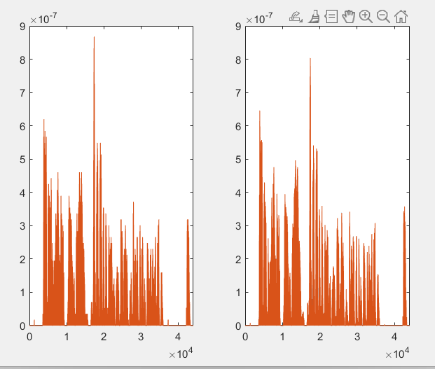

Figure 26 the magnitude spectrum of the second sgnal @4000 Hz.(input and output)

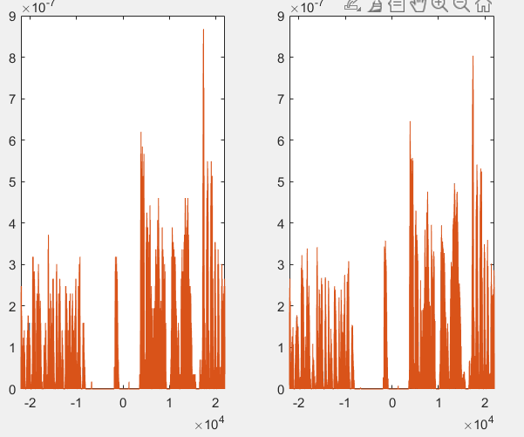

Figure 27 the magnitude spectrum of the first signal @4000 Hz.(input and output) (k) using fftshift’

# For modulation (D&E):

$p (t) = cos (ω0t)$*Equation 8*

# $r (t) = s(t) p(t)$*Equation 9*

*Where p(t) is the carrier signals(t) the signal and the r(t)is the modulated signal in time domain.*

## Explanation of my work:

First, we need to get the carrier signal which is (cos) as shown in *Equation 8* using section B of Amplitude modulation code, the we must make sure that the last frequency in the input signal as shown in section A of Amplitude modulation code (filtered signal with cut-off frequency 4000 Hz) does not interact with the carrier as shown in *Equation 10 and 11*.

# $R1\left(ω\right)=\frac{1}{2}*S1\left(ω-ωo1\right)+\frac{1}{2}*S1\left(ω+ωo1\right)$*Equation 10*

# $R2\left(ω\right)=\frac{1}{2}*S2\left(ω-ωo2\right)+\frac{1}{2}*S2\left(ω+ωo2\right)$*Equation 11*

# $Rtot\left(ω\right)=R1(w)+R2(w)$*Equation 12*

*Where S(w), P(w)and R(w) in frequency domain and 𝜔o is the frequency of carrier and 𝜔 is the frequency of the signal*.

Then we multiply the signals with different frequency and cosine as shown in *Equation 9*, then add each signal to get the modulation of two signal as shown in *Equation 12* using section C of Amplitude modulation code.

# We must make sure 𝜔0>𝜔1 to avoid any interaction between the modulated signal and the filtered signal.

Then we make the code tell the user which signal do you want to here (like the radio) as shown in section D of Amplitude modulation code, then after we chose the signal we design a band bass with right (Fpass & Fstop) to do the Demultiplexing of the selected signal as shown in *figure 28 and 29* using section E of Amplitude modulation code.

The we multiply the demultiplexed signal with carrier signal as shown in section F of Amplitude modulation code which have frequency we chose as shown in *figure 31*.

The last step is to design a low pass filter with gain 2 as shown in section H of Amplitude modulation code to get the output signal as shown in *figure 30*.

And this is the results.

Then, We play the signals to listen to them as shown in section Q of Amplitude modulation code

## The frequency response of the bandpass filter (7500 Hz)

Figure 28 Band paas filter for channel 1

## The frequency response of the bandpass filter (14500 Hz):

# .

Figure 29 Band paas filter for channel 2

## The frequency response of the lowpass filter (4000 hz):

# 

Figure 30 low paas filter for denoising



Figure 31 Transmitter and Receiver design

# Explanation of the steps of work flow chart:

The input signal

Get the carrier signal

Get the modulated signal to each signals and then adding the signal

Make a band bass filter to chose the signal we want to be modulated

Multiply the modulated signal with the carrier signal

Make a filter with gain (2)

Get the demodulated signal (output)

## For channel 1:

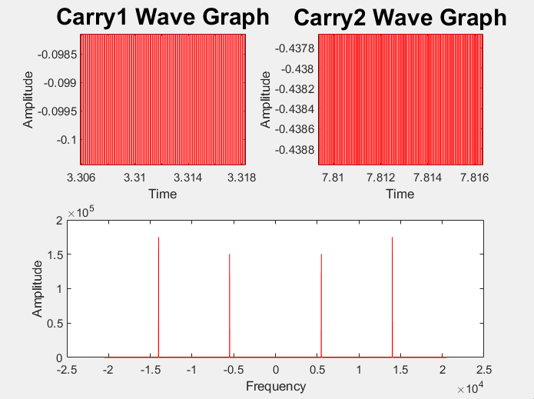

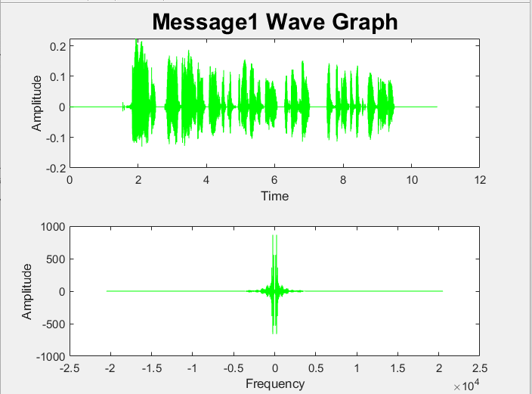

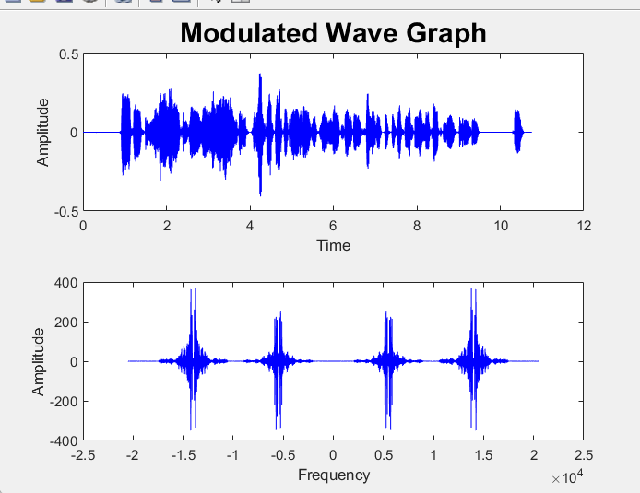

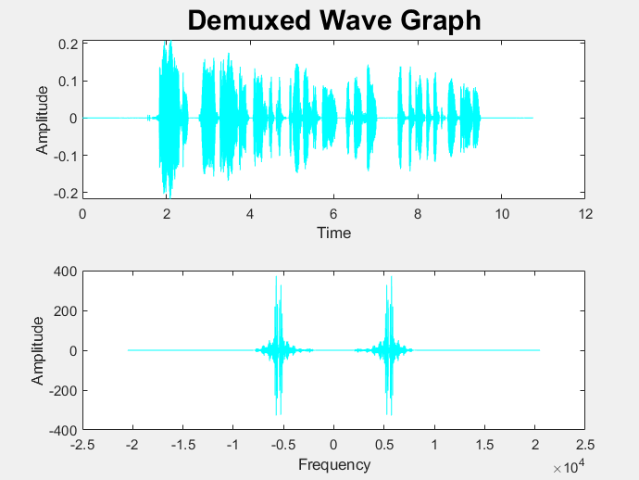

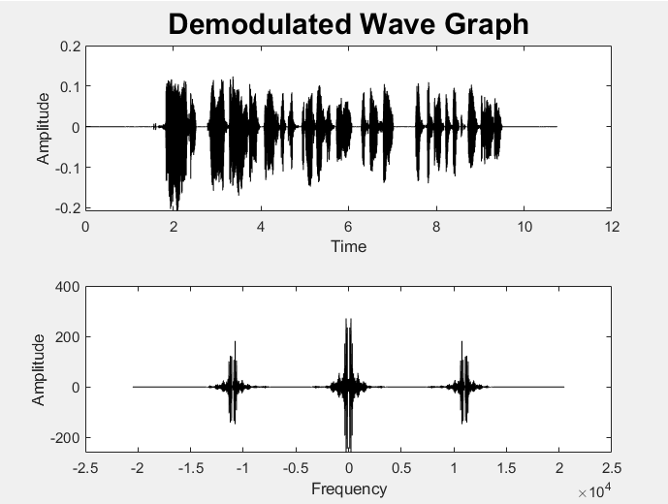

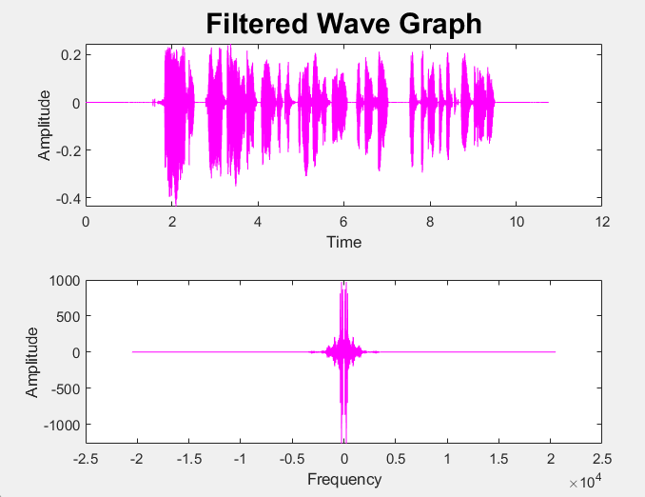

## For channel 2:



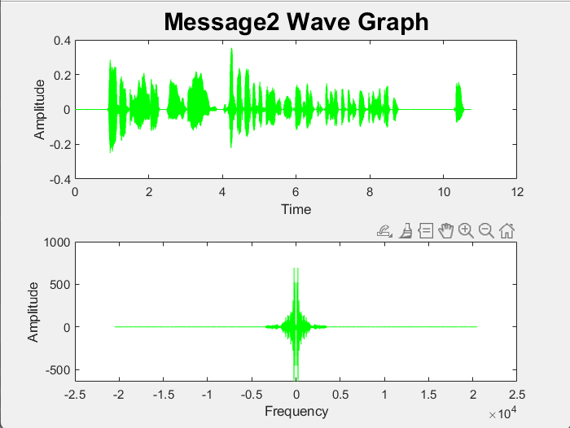

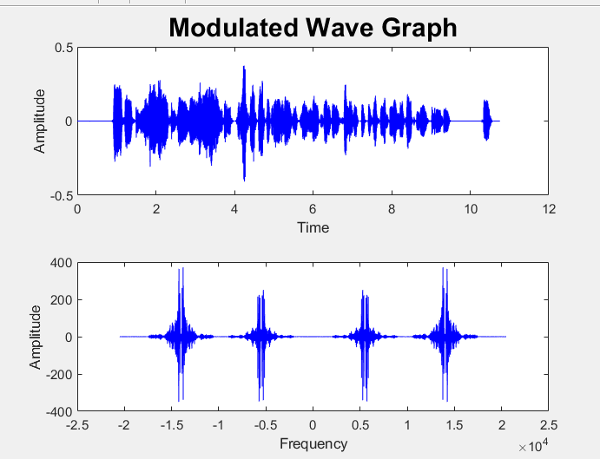

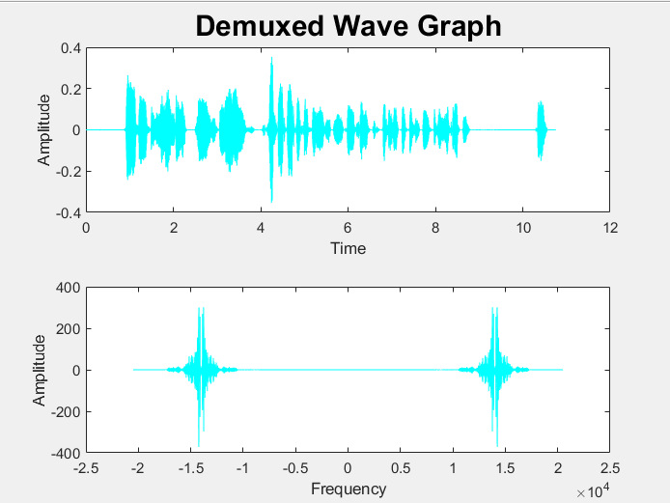

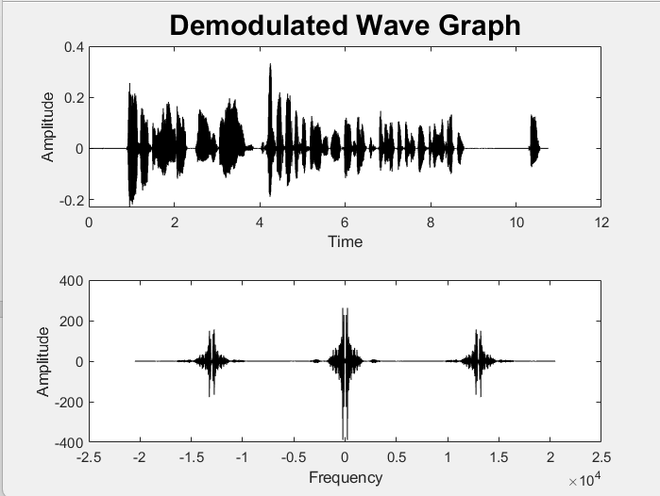

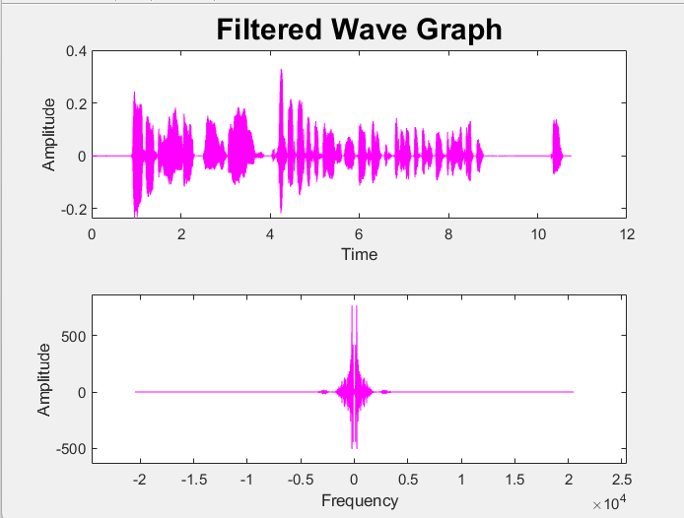

## Why we chose the carrier frequency(7500 Hz)&(16000 Hz)?

* because we the last frequency in the input signal is equal to (4500 HZ).we use the signal the we get from filter function in low frequency (Fstop=4500 Hz).so we use (7500 Hz) or (14500) as a carrier frequency to avoid any interaction between the modulated signal and the filtered signal[7].

**References:**

[1] <https://setosa.io/ev/image-kernels/>

[2] <https://www.youtube.com/watch?v=mbZeH9kdq3c&t=498s&ab_channel=ImageProcessing-JU>

[3] <https://en.wikipedia.org/wiki/Kernel_(image_processing)>

[4] <https://medium.com/@itberrios6/how-to-apply-motion-blur-to-images-75b745e3ef17#:~:text=The%20horizontal%20blur%20kernel%20(kernel,appear%20to%20be%20motion%20blurred>

[5] https://youtu.be/g3sfmjWkz5Q?si=Id_7uHqhuvtYGmvq

[6] <https://youtube.com/shorts/9B8JbDSmFVE?si=eBBULLV_15JEGgXk>

[7] https://youtu.be/IJuLmLyV-Sk?si=pFqW_1s3zZKZPjp-

# Appendix

## Image code:

clc %clear the command window

clear %clear the workspace to start

default =1; %if you want the default picture

%Section A

if default==1

pic=imread('peppers.png'); %default picture

else

[file,path]=uigetfile('*.*'); %locate the picture

picp=strcat(path,file); %picture path = "path"+"file"

pic=imread(picp); %read the picture

end

show_colors(pic); %show all colors

pause(3); %wait 3 seconds

%Section B

gray_pic=rgb2gray(pic); %get the gray picture

edge_kernel=[0 1 0; 1 -4 1;0 1 0]/90 %edge kernel

edge_pic = conv2(gray_pic, edge_kernel); %convelute the kernal with the picture

show_images(pic,edge_pic,"Orignal","Edge detection"); %show the orignal and edge picture

imwrite(edge_pic,"image1.png"); %save the edge picture

pause(3); %wait 3 seconds

%Section C

sharp_kernel = [0, -1, 0; -1, 5, -1; 0, -1, 0]/255 %sharp kernel

sharp_pic(:,:,1) = conv2(pic(:,:,1), sharp_kernel); %convelute the kernal with the red part of picture

sharp_pic(:,:,2) = conv2(pic(:,:,2), sharp_kernel); %convelute the kernal with the green part of picture

sharp_pic(:,:,3) = conv2(pic(:,:,3), sharp_kernel); %convelute the kernal with the blue part of picture

show_images(pic,sharp_pic,"Orignal","Sharp"); %show the orignal and sharp picture

imwrite(sharp_pic,"image2.png"); %save the sharp picture

pause(3); %wait 3 seconds

%Section D

blur_kernel=[1 2 1;2 4 2;1 2 1]/(16*255) %blur kernel

blur_pic(:,:,1)=conv2(pic(:,:,1), blur_kernel); %convelute the kernal with the red part of picture

blur_pic(:,:,2)=conv2(pic(:,:,2), blur_kernel); %convelute the kernal with the green part of picture

blur_pic(:,:,3)=conv2(pic(:,:,3), blur_kernel); %convelute the kernal with the blue part of picture

show_images(pic,blur_pic,"Orignal","Blur"); %show the orignal and blur picture

imwrite(blur_pic,"image3.png"); %save the blur picture

pause(3); %wait 3 seconds

%Section E

motion_kernel_size=19;

motion_kernel=[

0,0,0,0,0,0,0,0,0,0,0,0,0,0,0,0,0,0,0;

0,0,0,0,0,0,0,0,0,0,0,0,0,0,0,0,0,0,0;

0,0,0,0,0,0,0,0,0,0,0,0,0,0,0,0,0,0,0;

0,0,0,0,0,0,0,0,0,0,0,0,0,0,0,0,0,0,0;

0,0,0,0,0,0,0,0,0,0,0,0,0,0,0,0,0,0,0;

0,0,0,0,0,0,0,0,0,0,0,0,0,0,0,0,0,0,0;

0,0,0,0,0,0,0,0,0,0,0,0,0,0,0,0,0,0,0;

0,0,0,0,0,0,0,0,0,0,0,0,0,0,0,0,0,0,0;

0,0,0,0,0,0,0,0,0,0,0,0,0,0,0,0,0,0,0;

1,1,1,1,1,1,1,1,1,1,1,1,1,1,1,1,1,1,1;

0,0,0,0,0,0,0,0,0,0,0,0,0,0,0,0,0,0,0;

0,0,0,0,0,0,0,0,0,0,0,0,0,0,0,0,0,0,0;

0,0,0,0,0,0,0,0,0,0,0,0,0,0,0,0,0,0,0;

0,0,0,0,0,0,0,0,0,0,0,0,0,0,0,0,0,0,0;

0,0,0,0,0,0,0,0,0,0,0,0,0,0,0,0,0,0,0;

0,0,0,0,0,0,0,0,0,0,0,0,0,0,0,0,0,0,0;

0,0,0,0,0,0,0,0,0,0,0,0,0,0,0,0,0,0,0;

0,0,0,0,0,0,0,0,0,0,0,0,0,0,0,0,0,0,0;

0,0,0,0,0,0,0,0,0,0,0,0,0,0,0,0,0,0,0;

]/(motion_kernel_size*255); %motion kernel

motion_pic(:,:,1)=conv2(pic(:,:,1),motion_kernel); %convelute the kernal with the red part of picture

motion_pic(:,:,2)=conv2(pic(:,:,2),motion_kernel); %convelute the kernal with the green part of picture

motion_pic(:,:,3)=conv2(pic(:,:,3),motion_kernel); %convelute the kernal with the blue part of picture

[row,column] = size(motion_pic(:,: ,1)); %take the pic size

%show the orignal and motion picture

show_images(pic,motion_pic(19:row-19,19:column-19,:),"Orignal","Motion");

imwrite(motion_pic(19:row-19,19:column-19,:),"image4.png");

%save the motion picture and we reduce the frame

pause(3); %wait 3 seconds

%Section F

pad_motion_kernel = zeros(row,column); %intial the kernel

pad_motion_kernel(1: motion_kernel_size,1: motion_kernel_size) = motion_kernel;

%making the pad

%Fourier transform

motion_kernel_fft(:,:,1)=fft2(pad_motion_kernel); %fourier trasnform the motion lernel

motion_pic_fft(:,:,1)=fft2(motion_pic(:,:,1)); %fourier trasnform the red part

motion_pic_fft(:,:,2)=fft2(motion_pic(:,:,2)); %fourier trasnform the green part

motion_pic_fft(:,:,3)=fft2(motion_pic(:,:,3)); %fourier trasnform the blue part

RGB_scale=255*1e-19;

orignal_pic_fft(:,:,1) =motion_pic_fft(:,:,1) ./(motion_kernel_fft+RGB_scale);

%getting the orignal red part

orignal_pic_fft(:,:,2) =motion_pic_fft(:,:,2) ./(motion_kernel_fft+RGB_scale);

%getting the orignal green part

orignal_pic_fft(:,:,3) =motion_pic_fft(:,:,3) ./(motion_kernel_fft+RGB_scale);

%getting the orignal blue part

orignal_pic=255*ifft2(orignal_pic_fft); %inverse fourier transform

show_images(motion_pic(19:row-19,19:column-19,:),uint16(orignal_pic(19:row-19,19:column-19,:)),"Motion","Orignal");

%show the motion and orignal picture

imwrite(uint16(orignal_pic(19:row-19,19:column-19,:)),"image5.png");

%save the orignal picture and we reduce the frame

# Communication code:

clear;

clc;

load filters;

%section A %%%%%%%

%get the first input

[file1,path1]=uigetfile('*.*'); %The file locatioon

mp1=strcat(path1,file1); %The file path

[Ai1 ,fi1]=audioread(mp1); %Read the file

om1=audioplayer(Ai1,fi1); %make orignal audio object

%get the seond input

[file2,path2]=uigetfile('*.*'); %The file locatioon

mp2=strcat(path2,file2); %The file path

[Ai2 ,fi2]=audioread(mp2); %Read the file

om2=audioplayer(Ai2,fi2); %make orignal audio object

Ai1=low_filter(Ai1,fi1,1,low_pass);

Ai2=low_filter(Ai2,fi2,2,low_pass);

fm1=audioplayer(Ai1,fi1); %make filter audio object

fm2=audioplayer(Ai2,fi2); %make filter audio object

disp("first input");

play(om1); %play orignal audio

pause(10); %it plays it for 10 seconds

stop(om1); %stop orignal audio

disp("first input filtered");

play(fm1); %play orignal audio

pause(10); %it plays it for 10 seconds

stop(fm1); %stop orignal audio

disp("second input");

play(om2); %play orignal audio

pause(10); %it plays it for 10 seconds

stop(om2); %stop orignal audio

disp("second input filtered");

play(fm2); %play orignal audio

pause(10); %it plays it for 10 seconds

stop(fm2); %stop orignal audio

audiowrite("output1filter.wav",Ai1,fi1); %save the filtered file

audiowrite("output2filter.wav",Ai2,fi2); %save the filtered file

%%%%%%%%%

%section Bs %%%%%%%%

% first we will get the carrier signal in frequincy domain

Ai1=Ai1(:,1); %make it mono

Ai2=Ai2(:,1); %make it mono

A=1; %Carry amplitude

Fs=41000; %Sample frequency

fc1=5500; %Carry frequency

fc2=14000; %Carry frequency

Ts=1/Fs; %Sample period

N=length(Ai1); %Number of samples

t=[0:Ts:N*Ts-Ts]; %Time vector

f=[-Fs/2:Fs/N:Fs/2-Fs/N]; %Frequency vector

x1=A*cos(2*pi*fc1*t); %Carry

%second carrier signal

x2=A*cos(2*pi*fc2*t);

%Carry graph

figure(); %opens a figure

subplot(2,2,1); %divide it into half and plot the first half

plot(t,x1,'r'); %plot carry in time domain

xlabel("Time",'FontSize',10);

ylabel("Amplitude",'FontSize',10);

title("Carry1 Wave Graph",'FontSize',18);

subplot(2,2,2); %divide it into half and plot the first half

plot(t,x2,'r'); %plot carry in time domain

xlabel("Time",'FontSize',10);

ylabel("Amplitude",'FontSize',10);

title("Carry2 Wave Graph",'FontSize',18);

subplot(2,1,2); %second half

xft=fft(x1)+fft(x2); %Fourier transform

plot(f,fftshift(abs(xft)),'r'); %plot carry in frequency domain

xlabel("Frequency",'FontSize',10);

ylabel("Amplitude",'FontSize',10);

%Input1 graph

figure(); %opens a figure

subplot(2,1,1); %divide it into half and plot the first half

plot(t,Ai1,'g'); %plot input in time domain

xlabel("Time",'FontSize',10);

ylabel("Amplitude",'FontSize',10);

title("Message1 before filter Wave Graph",'FontSize',18);

subplot(2,1,2); %second half

Ai1_fft=fft(Ai1); %Fourier transform

plot(f,fftshift(Ai1_fft),'g'); %plot input in frequency domain

xlabel("Frequency",'FontSize',10);

ylabel("Amplitude",'FontSize',10);

%Input2 graph

figure(); %opens a figure

subplot(2,1,1); %divide it into half and plot the first half

plot(t,Ai2,'g'); %plot input in time domain

xlabel("Time",'FontSize',10);

ylabel("Amplitude",'FontSize',10);

title("Message2 Wave before filter Graph",'FontSize',18);

subplot(2,1,2); %second half

Ai2_fft=fft(Ai2); %Fourier transform

plot(f,fftshift(Ai2_fft),'g'); %plot input in frequency domain

xlabel("Frequency",'FontSize',10);

ylabel("Amplitude",'FontSize',10);

%%%%%%%%%%%%%%%%%

%secion C %%%%%%%%%%%%%%%%%

%Modulate

Ym=transpose(x1).*Ai1+transpose(x2).*Ai2;

figure(); %opens a figure

subplot(2,1,1); %divide it into half and plot the first half

plot(t,Ym,'b'); %plot modulated siganl in time domain

xlabel("Time",'FontSize',10);

ylabel("Amplitude",'FontSize',10);

title("Modulated Wave Graph",'FontSize',18);

subplot(2,1,2); %second half

Ym_fft=fft(Ym); %Fourier transform

plot(f,fftshift(Ym_fft),'b');%plot modulated siganl in frequency domain

xlabel("Frequency",'FontSize',10);

ylabel("Amplitude",'FontSize',10);

%%%%%%%%%%%%%%%%%

%section D %%%%%%%%%%%%%%%%%

%select which chanel

ch=0;

while ch ~=1 && ch~=2

ch=input("Which channel do you want?\n 1 or 2\n");

if ch ~=1 && ch~=2

disp("Invalid input");

end

end

%Channel selection

if ch==1

xs=x1;

As=Ai1;

fsel=fi1;

outname="1";

Hds=band_pass1;

filter_coef=4;

else if ch==2

xs=x2;

As=Ai2;

fsel=fi2;

outname="2";

Hds=band_pass2;

filter_coef=2;

end

end

%%%%%%%%%%%%%%%%%

%section E %%%%%%%%%%%%%%%%%

%demultiplexing

Ydemux=filter(Hds,Ym);

figure(); %opens a figure

subplot(2,1,1); %divide it into half and plot the first half

plot(t,Ydemux,'c'); %plot modulated siganl in time domain

xlabel("Time",'FontSize',10);

ylabel("Amplitude",'FontSize',10);

title("Demuxed Wave Graph",'FontSize',18);

subplot(2,1,2); %second half

Ydemux_fft=fft(Ydemux); %Fourier transform

plot(f,fftshift(Ydemux_fft),'c');%plot modulated siganl in frequency domain

xlabel("Frequency",'FontSize',10);

ylabel("Amplitude",'FontSize',10);

%%%%%%%%%%%%%%%%%

%section F %%%%%%%%%%%%%%%%%

Yd=Ydemux.*transpose(xs);

figure(); %opens a figure

subplot(2,1,1); %divide it into half and plot the first half

plot(t,Yd,'k'); %plot demodulated siganl in time domain

xlabel("Time",'FontSize',10);

ylabel("Amplitude",'FontSize',10);

title("Demodulated Wave Graph",'FontSize',18);

subplot(2,1,2); %second half

Yd_fft=fft(Yd); %Fourier transform

plot(f,fftshift(Yd_fft),'k'); %plot demodulated siganl in frequency domain

xlabel("Frequency",'FontSize',10);

ylabel("Amplitude",'FontSize',10);

%%%%%%%%%%%%%%%%%

%section H %%%%%%%%%%%%%%%%%

% filter with gain 2

Yf=filter_coef*filter(low_pass,Yd);

figure(); %opens a figure

subplot(2,1,1); %divide it into half and plot the first half

plot(t,Yf,'m'); %plot filtered siganl in time domain

xlabel("Time",'FontSize',10);

ylabel("Amplitude",'FontSize',10);

title("Filtered Wave Graph",'FontSize',18);

subplot(2,1,2); %second half

Yr_fft=fft(Yf); %Fourier transform

plot(f,fftshift(Yr_fft),'m'); %plot demodulated siganl in frequency domain

xlabel("Frequency",'FontSize',10);

ylabel("Amplitude",'FontSize',10);

%%%%%%%%%%%%%%%%%

%section K %%%%%%%%%%%%%%%%%

%let everthing stereo

xs=transpose(xs);

xs(:,2)=xs(:,1);

As(:,2)=As(:,1);

Ym(:,2)=Ym(:,1);

Yd(:,2)=Yd(:,1);

Yf(:,2)=Yf(:,1);

%listen to eveything

cm=audioplayer(xs,fsel);

im=audioplayer(As,fsel);

mm=audioplayer(Ym,fsel);

dmux=audioplayer(Ydemux,fsel);

dm=audioplayer(Yd,fsel);

fm=audioplayer(Yf,fsel);

disp("Carry");

%play(cm); %Warning

%pause(11);

disp("Input");

play(im);

pause(11);

disp("Modulate");

play(mm);

pause(11);

disp("Demux");

play(dmux);

pause(11);

disp("Demodulate");

play(dm);

pause(11);

disp("Filtered");

play(fm);

pause(11);

%%%%%%%%%%%%%%%%%

%section Q %%%%%%%%%%%%%%%%%

%save the file

audiowrite("carry.wav",x1+x2,fsel);

audiowrite("modulate.wav",Ym,fsel);

audiowrite("demodulate.wav",Yd,fsel);

audiowrite("output"+outname+".wav",Yf,fsel);

%%%%%%%%%%%%%%%%%

function [Af] = low_filter(A,f,input_num,low_pass_filter)

%LOW_FILTER Summary of this function goes here

% Detailed explanation goes here

Af=filter(low_pass_filter,A); %filter the audio

figure(); %opens a figure

N=length(A); %get the amplitude length

k=0:N-1; %calculating k

AF=fft(Af,N); %frequency shift the orignal

AI=fft(A,N); %frequency shift the filter

subplot(1,2,1); %divide it into half and choose the first half

plot(k,abs(AI));%draw the orignal audio

xlabel("K",'FontSize',10);

ylabel("Amplitude",'FontSize',10);

title("Input"+int2str(input_num)+" before filter Wave Graph",'FontSize',18);

subplot(1,2,2); %second half

plot(k,abs(AF));%draw the filter audio

xlabel("K",'FontSize',10);

ylabel("Amplitude",'FontSize',10);

title("Input"+int2str(input_num)+" after filter Wave Graph",'FontSize',18);

pause(3); %wait 3 seconds

figure(); %opens a figure

F=(0:N-1)*f/N; %calculate the frequency to plot it

subplot(1,2,1); %divide it into half and choose the first half

plot(F,abs(A)/N); %draw the orignal audio

xlabel("frequency",'FontSize',10);

ylabel("Amplitude",'FontSize',10);

title("Input"+int2str(input_num)+" before filter in frequncy domain",'FontSize',18);

subplot(1,2,2); %second half

plot(F,abs(Af)/N); %draw the filter audio

xlabel("frequency",'FontSize',10);

ylabel("Amplitude",'FontSize',10);

title("Input"+int2str(input_num)+" after filter in frequncy domain",'FontSize',18);

pause(3); %wait 3 seconds

figure(); %opens a figure

subplot(1,2,1); %divide it into half and choose the first half

plot(F,abs(fftshift(A))/N);%draw the orignal audio

xlabel("frequency",'FontSize',10);

ylabel("Amplitude",'FontSize',10);

title("Input"+int2str(input_num)+" before filter shifted frequency",'FontSize',18);

subplot(1,2,2); %second half

plot(F,abs(fftshift(Af))/N);%draw the filter audio

xlabel("frequency",'FontSize',10);

ylabel("Amplitude",'FontSize',10);

title("Input"+int2str(input_num)+" before filter shifted frequency",'FontSize',18);

end

function record_myvoice(Fs,Nseconds,input_num)

%RECORD Summary of this function goes here

% Detailed explanation goes here

warning off

ch=2; %Number of channels--2 options--1 (mono) or 2 (stereo)

datatype='uint8';

nbits=16; %8,16,or 24

% to record audio data from an input device ...

...such as a microphone for processing in MATLAB

recorder=audiorecorder(Fs,nbits,ch);

disp('Start speaking..')

%Record audio to audiorecorder object,...

...hold control until recording completes

recordblocking(recorder,Nseconds);

disp('End of Recording.');

%Store recorded audio signal in numeric array

x=getaudiodata(recorder);

%Write audio file

audiowrite("input"+int2str(input_num)+".wav",x,Fs);

end